Configuring pfsense
- Create a new VM
- Make sure “Typical (recommended)” is selected and click Next.
- Click “Browse” and navigate to the folder where your pfsense file is located.
- Rename your virtual machine “pfsense”
- Allocate at least 20GB of disk space and check off “Split virtual disk into multiple files”
- select “Customize Hardware”
- Allocate 2GB of memory and add 5 network adapters
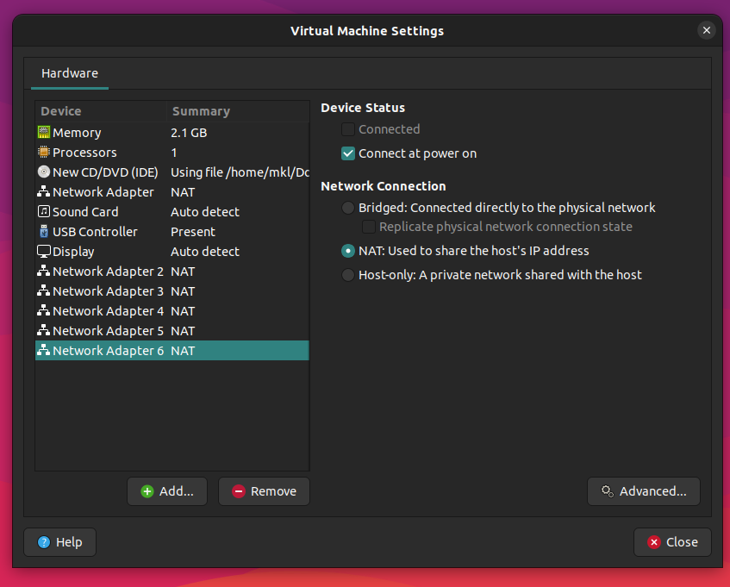

- Power on the pfsense machine and select all defaults. Pfsense will configure and reboot.
- Once finished you should see a screen like this:
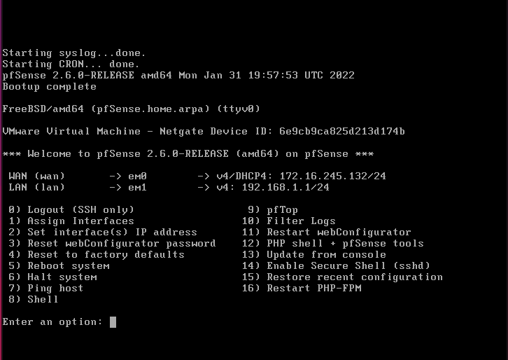
- Now we will assign interfaces. Choose option 1. Should VLANS be set up now [y:n]?: n
- Enter em0, em1, em2, em3, em4 & em5 respectively for each consecutive question.
- Screen should look like this:
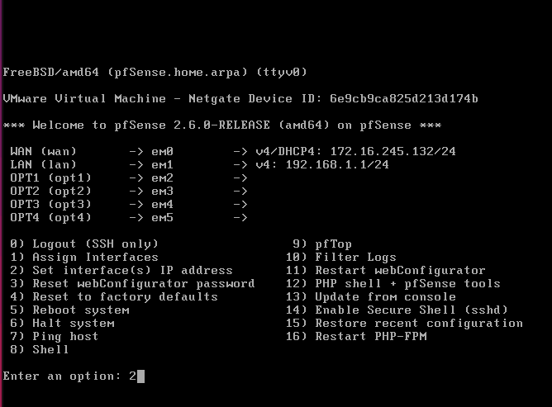
- We will set the IP for each option. Enter option 2 and select LAN interface (2)
- The IP address 192.168.1.1 is going to be used to access the pfsense WebGUI via the Kali Machine
- Screen should look like this:
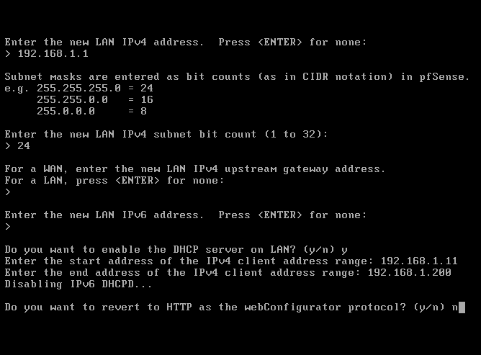
- Select OPT1 and input 192.168.2.1 for the IP address
- Select OPT2 and input 192.168.3.1 for the IP address
- We wont be touching OPT3 as it is going to have the span port with traffic that Security Onion will be monitoring
- Select OPT4 and input 192.168.4.1 for the IP address
- Our screen should look like this:
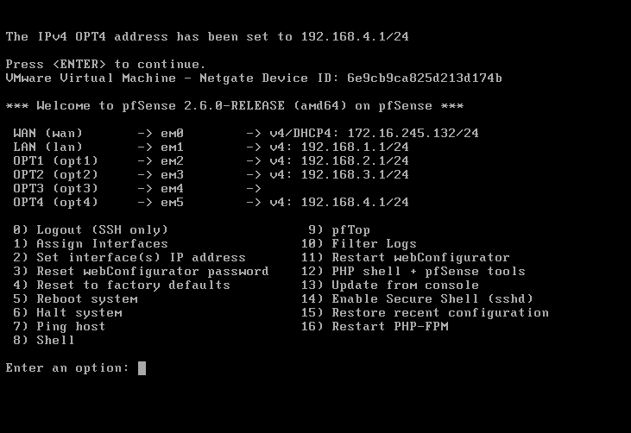

Configuring Security Onion
- This will be the all-in-one IDS, Security Monitoring, and Log Management solution.
- Same steps as installing pfsense.
- Find the ISO path for Security Onion. Choose linux → CentOS 7 64-Bit → Name it SecOnion
- Allocate a minimum of 200GB disk space and store it as a single file
- I recommend at least 16GB of memory allocated and 2 processors
- Once finished. Boot up the VM and choose graphical installing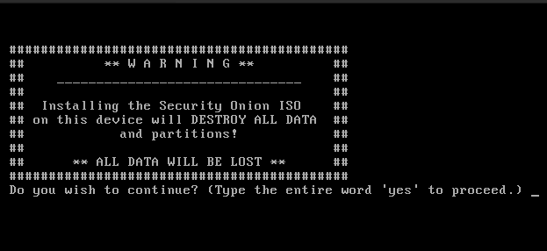
- Type ‘yes’
- set a username and password. SecOnion will reboot.
- This will be very straightforward.
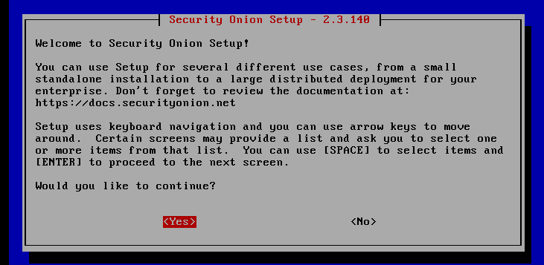
- Select YES.
- Select Install
- Select EVAL
- TYPE “AGREE”
- Select Standard
- Set a hostname and a short description if needed
- Select ens33 and set it as DHCP to configure the management interface
- Select ens35 and select all defaults
- Enter an email and password for the admin account
- Select IP – use the IP address to access the web interface
- Leave NTP Servers as default
- REMEMBER THIS PAGE AS IT CONTAINS THE ACCESS URL TO SECONION
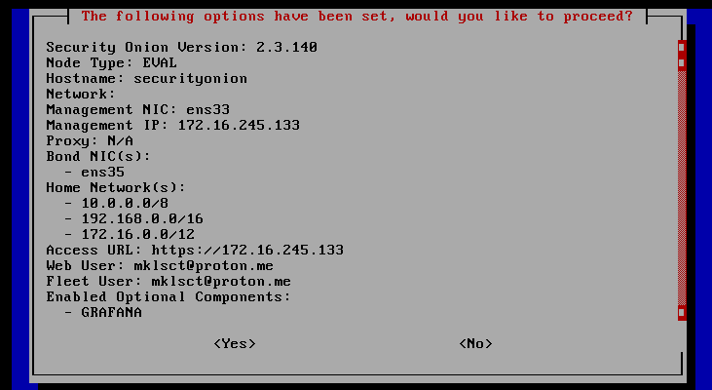

SecOnionMgmt/ Analyst Machine

- After installing Security Onion, we will be accessing the web interface from an external Ubuntu Desktop simulating a SOC/Security Analyst accessing a SIEM.
- I recommend setting up a bare-bones ubuntu desktop VM. All you need is access to the terminal and a web-browser.
- Once you have that setup. Pull the IP Address from the Ubuntu Machine as we’ll need this to setup an analyst role in SecOnion.
- Lets go back to our SecOnion instance and run the command “sudo so-allow”

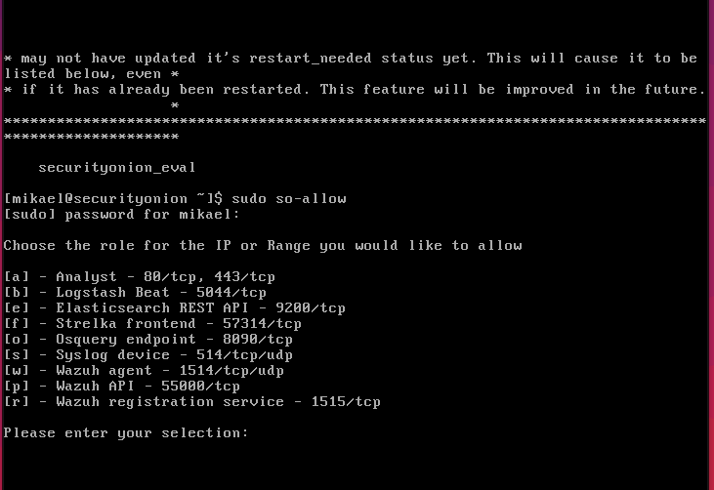
- Type [a]. Then enter the IP Address from our Ubuntu machines
- What we did was create a rule in SecOnion to allow us web access from our Ubuntu machine.
- Let’s head back to our Ubuntu machine and type our SecOnion IP Address in the web browser.
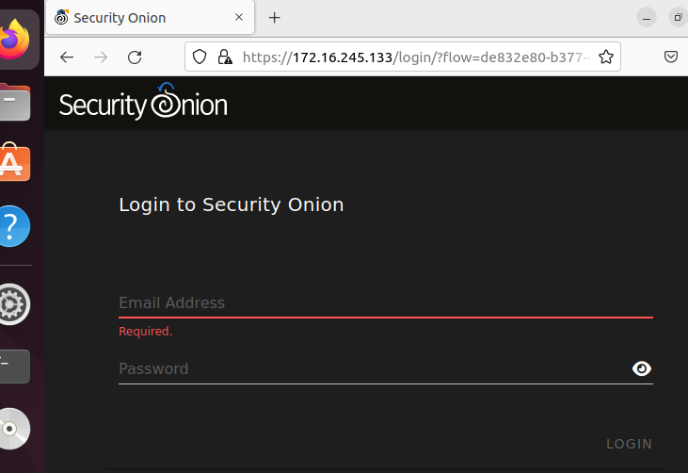
- Log-in

We’re in!
That concludes the setup of pfsense and security onion. Next I will be setting up an attack machine with Kali linux and configuring my pfsense firewall.

